ReadMe from: https://github.com/mtornga/PiSensorNetwork
PiOT
Creating some IoT-type devices for around the house and having them report back to a main node. The current thrust of PiOT collects temperature and humidity data.
Result 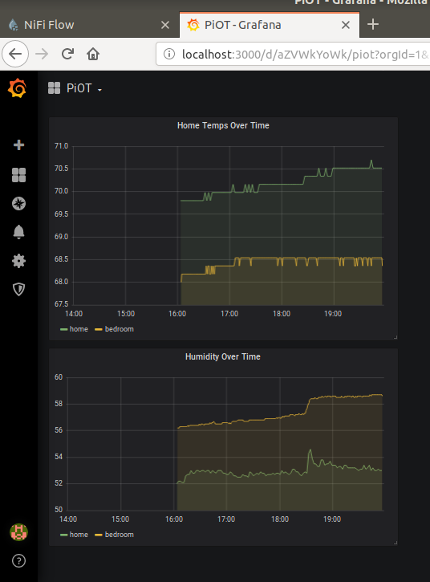
Architecture:
Technologies Demonstrated:
- Docker
  - Creating containers in a network
  - Automating deployment of the stack
  - Exposing ports to localhost
- MySQL
  - Database and table creation
  - Light ETL
  - Event manager for scheduling actions
- Nifi
  - InvokeHTTP for scheduling HTTP GET requests
  - PutDatabaseRecord for converting JSON into INSERT statements
  - Processor templating
- Python3
  - Flask for hosting a RESTful API
  - Command-line arguments
  - Writing to a SQLite database
- SQLite
- Crontab
- DH22 Sensor

Deploying on a new Pi
Deployed and tested on Raspberry Pi versions 3b+, 4, and Zero W with the full Raspian installation.

Preparing the Raspian environment
Raspian was installed using the NOOBS thing where the OS is loaded on the SIM card for the user. I will try to script the installation of these other pre-reqs:
- Python3
- Adafruit DHT
- Git
sudo apt update sudo apt-get update && sudo apt-get upgrade -y (something like this) sudo apt-get install python3 sudo apt-get install git mkdir repos && cd repos git clone https://MarkTornga@bitbucket.org/MarkTornga/piot.git mkdir /home/pi/data then run CreateSensorDB
installing adafruit dht stuff sudo python3 -m pip install --upgrade pip setuptools wheel sudo pip3 install Adafruit_DHT git clone https://github.com/adafruit/Adafruit_Python_DHT.git sudo python3 setup.py install
Run pinout to get the GPIO info and then attach the sensor. Plus to power, minus to ground, out to a GPIO pin
Enable ssh access: sudo systemctl enable ssh sudo systemctl start ssh
Assign static IP

Setting up the home base
In nifi, have to upload template, add template to tthe canvas, in DBCPConnectionPool controller service: Databse connection URL will need to do docker inspect network web to find the ip for the finaldb container have to set the password parameter

